Tentative Plan for the Course, OOP using Java (CSE203)
Java Mini Project
The proposed Java Mini Project architecture integrates JavaFX as the frontend interface and Core Java as the backend implementation layer. The backend incorporates Object-Oriented Programming concepts, Java Collections, Data Structures and Algorithms to implement good application logic and problem-solving. JDBC serves as the database connectivity layer between the Java application and the MySQL, MS Access database for persistent data storage and retrieval.
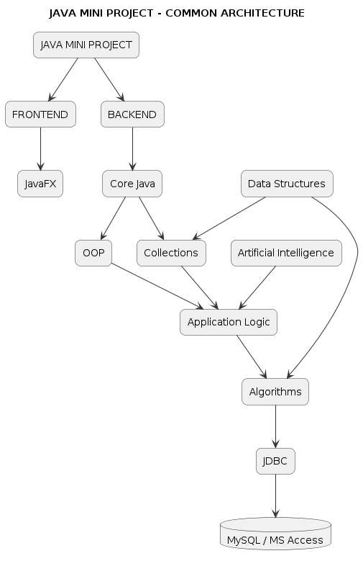

Milestone 1:
Team Formation and Role Allocation
Students will be divided into teams of 4–5 members, with clearly defined roles and responsibilities (such that all the students work on coding) to promote effective collaboration and individual accountability
- Every student must contribute code.
- Students must rotate roles during development.
  - Each student must be able to explain the complete project during the viva
Roles
Team Coordinator – manage timeline and meetings
JavaFX Lead – coordinate UI development
Core Java & OOP Lead – coordinate application classes and business logic
DSA & Database Lead – coordinate data structures, algorithms, and JDBC
Milestone 2:
Students will be introduced to the common technical architecture of the mini project. They will be allowed to select a project and analyse the basic requirements, functionalities, DB Design and techniques to be used to build the project.
Milestone 3:
Expert Led Hands-on Full-Stack Project Session
An expert session is planned to be organized to demonstrate the development of a simple end-to-end Java full-stack application as per the syllabus and mini-project architecture.
Milestone 4:
Promotion of Self-Learning and Exploration through use of Project Building Tools & AI Tools
Students will be encouraged to independently explore relevant technologies, documentation, tutorials, and learning resources.
- Git + GitHub - "Collaborative Software Development Practices"
- GitHub Copilot - AI Coding Assistant
- ChatGPT/Claude/Gemini - Learning, Debugging & Code Assistance
Milestone 4:
Teamwork, Presentation, and Technical Documentation
Students will be guided to work collaboratively, maintain proper project documentation, and present their project outcomes effectively. Each team will be expected to demonstrate the working application, explain the technical implementation, and submit a structured project report.

S. No. | Evaluation Criteria | Marks
1 | Problem Identification & System Design | 10
2 | Java & Data Structures Implementation | 15
3 | Application Development & Database Integration | 10
4 | Teamwork, Git/GitHub & Individual Contribution | 10
5 | Documentation, Presentation & Individual Viva | 5
 | TOTAL | 50

Quiz:
Quiz – Programming-Based Practical Assessment
The students will be provided with computer systems having JDK installed and no internet connectivity. A question paper containing programming-based tasks will be provided to each student. The assessment will evaluate the students' ability to analyze, debug, modify, and complete Java programs based on the concepts covered in the course.
The quiz may include the following types of tasks:
- Debugging: Identify bugs, correct the program.
- Syntax Correction: Identify and rectify syntax and compilation errors.
- Code Completion: Complete the missing portions of a partial Java program/ loops/ methods for the given task, and given output.
- Exception Handling: Modify or complete a Java program to appropriately handle exceptions using suitable exception-handling mechanisms.
The assessment will be conducted individually under controlled laboratory conditions without internet access, ensuring fair evaluation of students' programming skills and conceptual understanding.

List of Mini Project ideas (Students ideas can be also encouraged)
Digital Queue Token Generator – Manage tokens for campus offices.
Classroom Seat Allocation System – Allocate seats based on register number and capacity.
Smart Parking Slot Finder – Assign available parking slots based on vehicle type.
Smart Canteen Token System – Generate food-order tokens and manage serving queues.
Campus Event Registration System – Manage event registrations and prevent duplicates.
Automated Java Code Quality Checker
Digital Peer Code Review System
Personalized Timetable Generator
AI-Based Study Planner
Smart Waste Bin Monitoring
Campus Lost & Found Portal
QR Attendance System
Campus Event Portal
AI Resume Screening System
AI Timetable Generator
AI Interview Question Generator
AI Academic Advisor
Fake News Detector
AI Question Paper Difficulty Analyzer
Smart Classroom Management System – Manage students, faculty, attendance, and assignments.
Hospital Emergency Priority System – Prioritize patients based on emergency levels.
Campus Club Management System – Manage clubs, memberships, events, and participation.
Online Food Ordering System – Manage food, orders, discounts, and payments.
Online Bus Booking System
Digital Queue Token Generator – Manage tokens for campus offices.
Classroom Seat Allocation System – Allocate seats based on register number and capacity.
Smart Parking Slot Finder – Assign available parking slots based on vehicle type.
Smart Canteen Token System – Generate food-order tokens and manage serving queues.
Campus Event Registration System – Manage event registrations and prevent duplicates.
Automated Java Code Quality Checker
Digital Peer Code Review System
Personalized Timetable Generator

